



Weekly Movie Nights, Sundays at 6:00pm  
Presenting one or two episodes of “The Chosen,” season 1 & 2, each week. Free popcorn & snacks!

**Happenings In & Around Machias:**

**Odosagih Bible Conference, 3204 Hazelmere Ave**Oct 8-11 Speaker – Dr. Deone Drake   
Musician – Cheri Taylor Oct 9 Concert – Cheri Taylor   
Call 716-353-8555 to make reservations for dinner.

  
located at 10451 Ashcraft Rd, Delevan, NY

**Presents “The Wild West Fall Fest”!  
Saturday, October 23, 1:00 -6:00 P.M.**  
Entry Fee $5 (per car)  
Multiple Vendors, Food Trucks, Lasertron, Rock Wall Climbing, Pumpkin Launching, Pie Eating, Hay Rides, Concert & More!  
(Pre-register and get a free round of Lasertron) 1-800-231-6866.

**King Memorial Library:** Open Mon & Wed 12 Noon to 6 pm; Tues 10 am-3 pm; Thurs 10 am to 6 pm (716-353-9915)

#### Cattaraugus County Stone House Museum, 9824 Route 16 **Open: Mon - Thurs**, 9:00am to 4:00pm, and the **third Saturday of each month**, May through October, from 10:00AM-2:00PM.

#### Free Community Dinner Sun, Oct 31st at 5:00 pm in the First Christian Church Fellowship Hall.

**“First Christian Chatter!”**

**October 2021**



**Seeking to Know Jesus and Make Him Known**

**9658 Main Street, PO Box 14, Machias, NY 14101  
716-353-4171;** [**https://fccmforhope.org**](https://fccmforhope.org)

**Or Follow us on FaceBook**

**Pastor Ross Thompson  
716-481-9348**

[**pastorross.fccm@gmail.com**](mailto:pastorross.fccm@gmail.com)

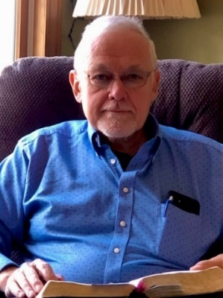

**A Note from Pastor Ross**

**If you own a car or a home, you are aware of the ongoing maintenance a house or a vehicle needs in order to prevent deterioration**, especially as winter approaches. At our home we have to change the garden tractor/lawn mower over to tractor/snowblower. And we just had the car and truck sprayed underneath with rust inhibitor because we know the salt will be on our roads soon. Have you noticed the pickup trucks that didn’t get undercoated? After a few years the rust really shows, and those trucks are expensive, even the used ones. Being faithful with preventative maintenance is the key to long term life for a vehicle or a house or other man-made items, isn’t it?  
**Faithful maintenance is also key to healthy spiritual and mental life**. Jesus compares that kind of faithful attention to detail in little physical things to the more important spiritual parts of our life. Here’s what He says in **Luke 16.10-12:**

“**10**“**If you are faithful in little things,** you will be faithful in large ones. But if you are dishonest in little things, you won’t be honest with greater

responsibilities. **11And if you are untrustworthy about worldly wealth, who will trust you with the true riches of heaven? 12**And if you are not faithful with other people’s things, why should you be trusted with things of your own?  
**May the items you need to maintain at your house not make you sad, but make you glad** that have the opportunity to show that you are faithful in little things, and therefore, can be counted on to also be faithful in the bigger things of heaven and earth. Smile as you change that oil and wash those windows.

*Have a prayer concern? Drop a note in the prayer box at church, or send Pastor Ross a text or email.*

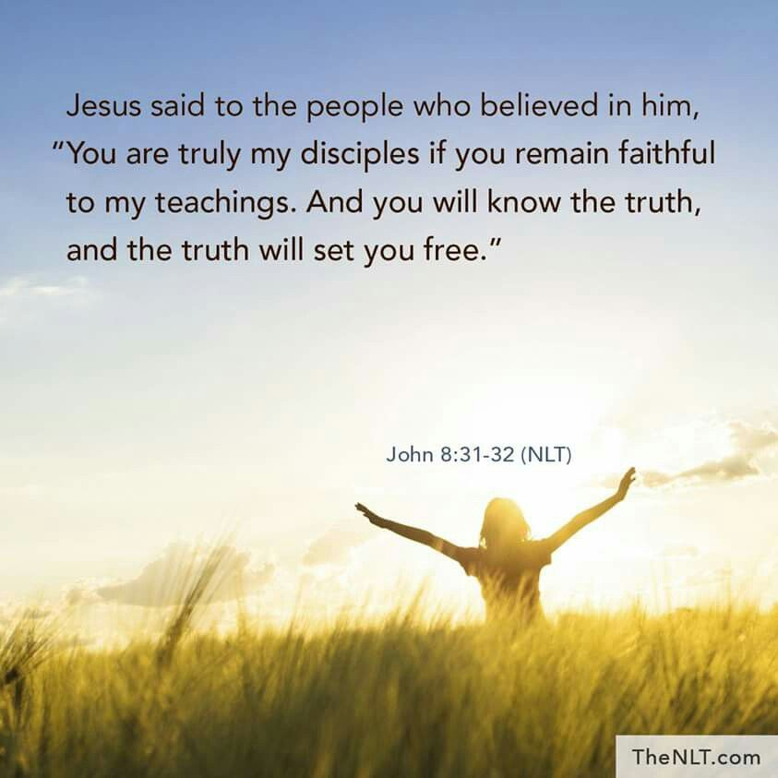



**Sunday Morning Adult Bible Study** on “How We Got the Bible” at 9:15 A.M. in the Fellowship Hall

**Worship Service** every Sunday at 10:30 A.M.   
**Children’s Church & Nursery available during worship.**  
Children's Church is available for children 4 years old - 6th grade. They are dismissed after the singing time to learn about Jesus through Bible stories and concepts at appropriate age levels including fun activities.  
Our nursery is adjacent to the sanctuary.  It is available during Sunday morning service for ages 0-3.  It is staffed by at least 1 adult and 1 helper.

**Free Food Give-Away every Sunday, 12-1:30 pm***No financial qualification needed  
Oc*t Dates: 10/3, 10/10, 10/17, 10/24, 10/31

**The Lord’s Supper -**remembering what Jesus has done for us, during worship on Sunday, Oct 3.  
**Missionary Sunday, Oct 10 – Guest Speaker,   
Dr.Paul Devakumar of India For Christ**

**Prayer Gatherings:** Jesus said that His Father's house is a house of prayer.  Please join us for Prayer  
Sundays – 8:00 A.M.; Tuesdays – 3:00 P.M.  
Thursdays – 6:30 P.M.

**Midweek Bible Study –** Tuesday at 6:30 P.M.  
**Youth Group** – Meets Wednesdays at 6:00 P.M.  
**Movie Nights:** Sundays, 6:00 pm Free popcorn!

**Women’s Bible Study & Prayer** – Wed, Oct 13, 1:00 P.M.

**Free Community Dinner**:Sun, Oct 31st at 5:00 pm in the Fellowship Hall.