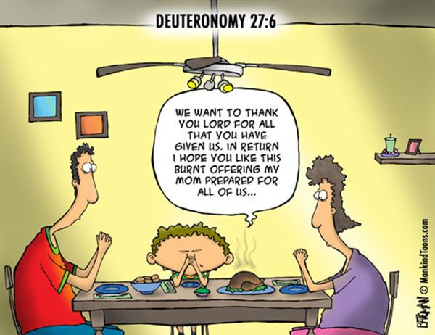



Weekly Movie Nights, Sundays at 6:00pm   
Presenting an episode of “The Chosen,” Season 2, each week. Free popcorn & snacks!

****It’s that time of year! Pick up, pack, bring back!  
Please return no later than Nov 14!

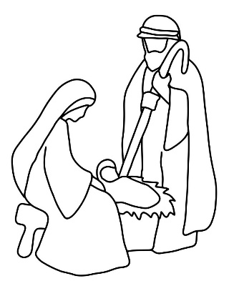

**Christmas Variety Program at FCCM**   
Fri, Dec 3, 7:00 P.M. followed by a Tureen Supper  
Open to any performers who would like to present Skits, Instrumental selections, Vocal selections, Narratives, Poems or Readings, which are Christ-centered. For more info, or to Sign -up, contact Ann Parker, 716-353-4107, or anna242parker@yahoo.com

#### 

#### Free Community Dinner Sun, Nov 28th at 5:00 pm in the First Christian Church Fellowship Hall.



Saturday, Nov. 13, 9:30 a.m. to Noon in the Fellowship Hall.

**“First Christian Chatter!”**

**November 2021**



**Seeking to Know Jesus and Make Him Known**

**9658 Main Street, PO Box 14, Machias, NY 14101  
716-353-4171;** [**https://fccmforhope.org**](https://fccmforhope.org)

**Or Follow us on FaceBook**

**Pastor Ross Thompson  
716-481-9348**

[**pastorross.fccm@gmail.com**](mailto:pastorross.fccm@gmail.com)

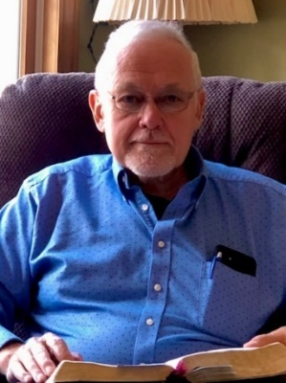

**A Note from Pastor Ross**

**Have you noticed how good you feel when you are thankful**? It brings joy to your mind and lightness to your steps! The opposite is true also: chronic complainers are miserable. Because of their constant complaining God left the nation of Israel in the wilderness much longer (40 years) than would have been the case if they had been constantly thankful to Him.

One of the great things about November in the USA is a special day that reminds us to be Thankful to the LORD. As you prepare for your Thanksgiving Day this month, please remember this benefit for those who are thankful:

Thankful people avoid darkness and receive great spiritual light: [Romans 1:21](https://www.biblegateway.com/passage/?search=Romans%201%3A21&version=NKJV) **“ be**cause, although they knew God, they did not glorify *Him* as God, nor were **thankful**, but became futile in their thoughts, and their foolish hearts were darkened.”

**Not being consistently thankful leads us to foolish, futile thoughts and spiritual darkness.** Knowing about God is not enough. We each need to glorify Him and thank Him even when we don’t like what is going on in our lives.

**As the Bible says,** ***the only way to enter into God’s presence is through*** being a person who daily praises and thanks God for who He is and how gracious He is to us each day: [Psalm 100:4](https://www.biblegateway.com/passage/?search=Psalm%20100%3A4&version=NKJV)

“Enter into His gates with thanksgiving, *And* into His courts with praise. **Be** **thankful** to Him, *and* bless His name.”

**Happy Thanksgiving!**

*Have a prayer concern? Drop a note in the prayer box at church, or send Pastor Ross a text or email.*

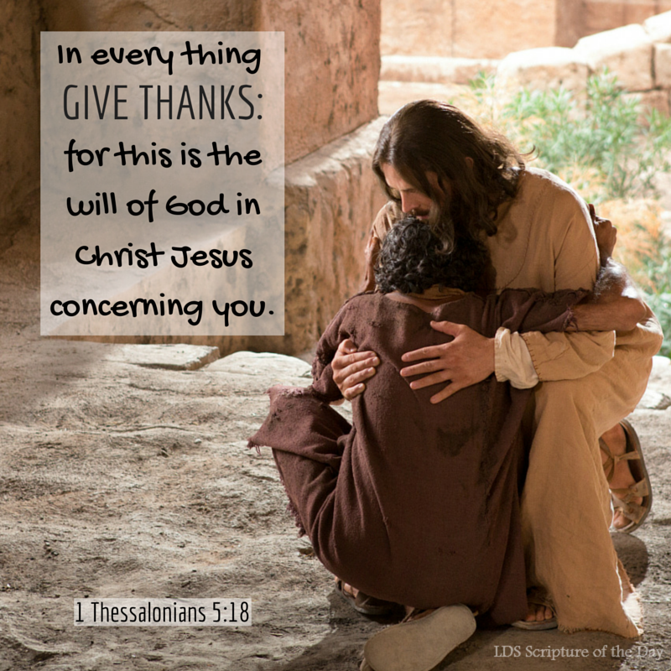



**Sunday Morning Adult Bible Study** on “The Bible” at 9:15 A.M. in the Fellowship Hall

**Worship Service** every Sunday at 10:30 A.M.   
**Children’s Church & Nursery available during worship.**  
Children's Church is available for children 4 years old - 6th grade. They are dismissed after the singing time to learn about Jesus through Bible stories and concepts at appropriate age levels including fun activities.  
Our nursery is adjacent to the sanctuary.  It is available during Sunday morning service for ages 0-3.  It is staffed by at least 1 adult and 1 helper.

**Free Food Give-Away every Sunday, 12-1:30 pm***No financial qualification needed  
Nov* Dates: 11/7, 11/14, 11/21, 11/28

**Prayer Gatherings:** Jesus said that His Father's house is a house of prayer.  Please join us for Prayer  
Sundays – 8:00 A.M.; Tuesdays – 3:00 P.M.  
Thursdays – 6:30 P.M.

**Midweek Bible Study –** Tuesday at 6:30 P.M.  
**Youth Group** – Meets Wednesdays at 6:00 P.M.  
**Movie Nights:** Sundays, 6:00 pm Free popcorn!

**Women’s Bible Study & Prayer** – Wed, Nov 10, 1:00 P.M.

**New Members Class** – Sat, Nov 13, 9:30 A.M. to Noon

**Fellowship Sunday, Coffee & Donuts!** Nov 28, 9:15 A.M.

**Free Community Dinner**:Sun, Nov 28 at 5:00 P.M. in the Fellowship Hall.