

**Election of Church Officers and adoption of church budget will take place Sun, April 24, immediately following worship.**

Church Members are asked to Pray for the Holy Spirit’s leadership in preparation for this meeting. May He call out His chosen leaders to fill the needed roles in our congregation. Is God Calling you? Speak to Pastor Ross or an Elder: Bob Breton, Pete Andrews, John Hubbard or Mack Bixby.

****,

**Drop-off days:** Tues, Feb 1st, 6-9 pm & Wed, Feb 2, 11:30-2:30 pm. **Pick-Up Days:** Fri, Feb 4, 6-9 pm & Sat, Feb 5, 9am -12 Noon. Over 65 years old may come an hour early to pick up.  
Workers need to help sort and set up. Prayer warriors needed during the exchange, Fri, Feb 4, 6-9 pm and Sat, Feb 5, 9 am to Noon. Workers also need to pack up after the exchange, beginning at noon on Saturday,



Saturday, Feb. 19, 9:30 a.m. to Noon in the Fellowship Hall.

**February Missions Project:**

#### 

#### 

#### Free Community Dinner Sun, Feb 27th at 5:00 pm in the First Christian Church Fellowship Hall.

#### Food provided. Bring a dish to pass if you desire.

**“First Christian Chatter!”**

**February 2022**

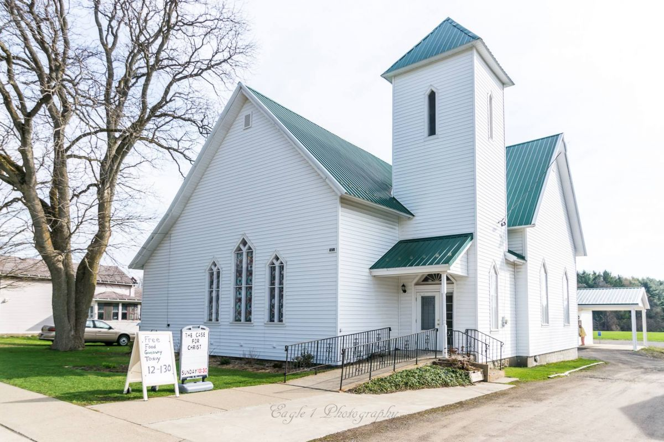

**Seeking to Know Jesus and Make Him Known**

**9658 Main Street, PO Box 14, Machias, NY 14101  
716-353-4171;** [**https://fccmforhope.org**](https://fccmforhope.org)

**Or Follow us on FaceBook**

**Pastor Ross Thompson  
716-481-9348**

[**pastorross.fccm@gmail.com**](mailto:pastorross.fccm@gmail.com)

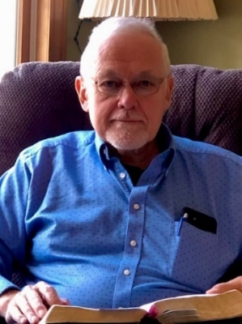

**A Note from Pastor Ross**

**February is a great month for at least two reasons:** Valentine’s Day reminds us of the central role of love in a life well lived and February gives us a heads up about Spring time being just a few weeks away.

Jesus summed up the entire Old Testament with this statement about love to a lawyer who had asked Him what is the greatest commandment: **Matthew 22:**

“37 Jesus said to him, “‘You shall **love the Lord** your God with all your heart, with all your soul, and with all your mind.’ 38 **This is the first and great commandment.** 39 And **the second** is like it: ‘You shall **love your neighbor as yourself.’** **40 On these two commandments hang all the Law and the Prophets.”**

Let me challenge myself and you in this new month of February…study what it means to love God and love people. The Bible has much to say about both. A good place to start is in Hebrew 13.1 which says: **“Let brotherly love continue.”** If love for people was automatic, we wouldn’t need to be encouraged to “continue in brotherly love”. Let your love for Jesus continue as shown by doing what He says. The next verse in Hebrews 13 gives one way to show love to another person: Vs 2. “Do not forget to entertain strangers, for by so *doing* some have unwittingly entertained angels.”

Wouldn’t that be awesome? Being hospitable to someone we might even think of as a stranger. Let’s take someone to lunch or invite them over to our home for coffee, a snack, and a chance to get to know them. **2**Do not forget to entertain strangers, for by so *doing* some have unwittingly entertained angels. And let your hope for Spring time grow as you watch for the first Robin to show up **in** your yard. Who will see the first one?

*Have a prayer concern? Drop a note in the prayer box at church, or send Pastor Ross a text or email.*

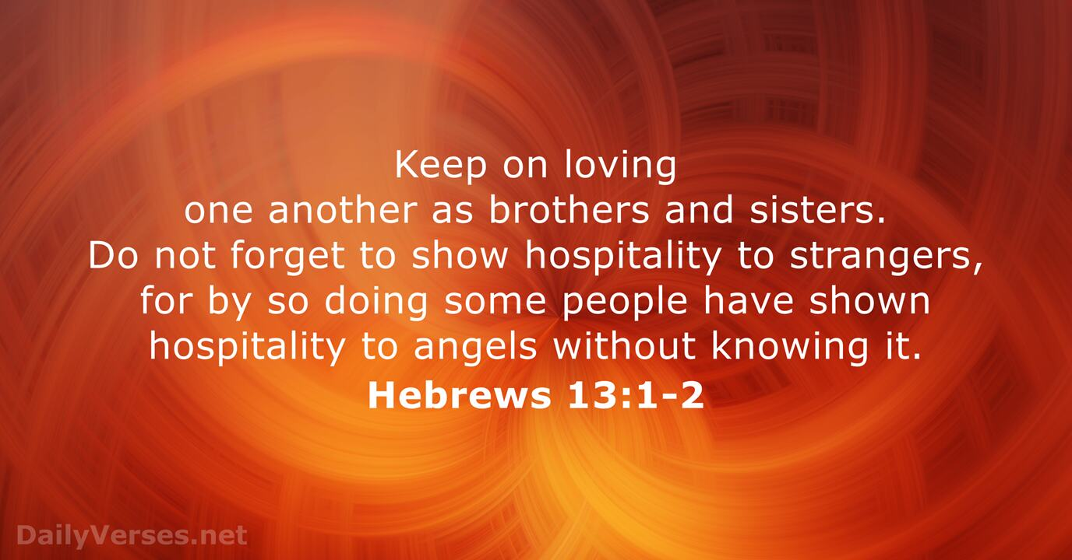

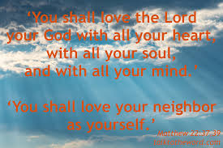



**Sunday Morning Adult Bible Study** on “Sharing Your Testimony” at 9:15 A.M. in the Fellowship Hall

**Worship Service** every Sunday at 10:30 A.M.   
**Children’s Church & Nursery available during worship.**  
Children's Church is available for children 4 years old - 6th grade. They are dismissed after the singing time to learn about Jesus through Bible stories and concepts at appropriate age levels including fun activities.  
Our nursery is adjacent to the sanctuary.  It is available during Sunday morning service for ages 0-3.  It is staffed by at least 1 adult and 1 helper.

**Free Food Give-Away every Sunday, 12-1:30 pm***No financial qualification needed  
February* Dates: 2/6, 2/13, 2/20, 2/27

**Prayer Gatherings:** Jesus said that His Father's house is a house of prayer.  Please join us for Prayer  
Sundays – 8:00 A.M.; Tuesdays – 3:00 P.M.  
Thursdays – 6:30 P.M.

**Midweek Bible Study –** Tuesday at 6:30 P.M.  
**Youth Group** – Meets Wednesdays at 6:00 P.M.  
**Movie Night:** Sun, Feb27, 6:00 pm “God, Where Are You?” Free popcorn!

**Free Clothing Exchange! Feb 1-2:** Drop-off days  
**Feb 4 & 5**: Pick-Up Days. **New Members Class** – Sat, Feb 19, 9:30 A.M. to Noon

**Fellowship Sunday, Coffee & Donuts!** Feb 27, 9:15 A.M.

**Free Community Dinner**:Sun, Feb 27 at 5:00 P.M. in the Fellowship Hall.